SAFEHUB: AI INTEGRATION FOR STUDENT WELFARE SERVICES SPECIFYING ON APPOINTMENT SERVICES
Roi Nathaniel Ballesteros
Jon Alfred Bernabe
Rameses Soraya Cruz
Hanz Philip Manaog
John Christian Rosuelo
La Consolacion University Philippines, City of Malolos, Bulacan

ABSTRACT
SafeHub is a web-based application designed to support the appointment services and welfare programs of the Student Welfare Services (SWS) Office at La Consolacion University Philippines (LCUP). The system responds to challenges such as limited counseling slots, manual documentation, and the growing mental health needs of students in a technology‑driven environment. It integrates an AI‑assisted chatbot for low‑intensity support, appointment scheduling, mood tracking, and a news feed for mental‑health‑related announcements while enforcing strict data privacy and role‑based access control.
The study aimed to (1) integrate significant features that support student mental health and appointment services, (2) test the system’s functionality through structured test cases, and (3) evaluate the system using the ISO/IEC 25010:2023 software quality model based on student end‑user evaluation, SWS counselor review, and IT expert review. The system was developed using Agile methodology with a Kanban framework, implemented with a React–Next.js frontend, Prisma and PostgreSQL backend, and AI integration through a large language model provider. Ninety functional test cases were executed across student, counselor, and administrator roles, all of which passed. SafeHub was evaluated by thirty-four (34) LCUP student end‑users, two (2) SWS counselors, and three (3) IT experts using a 5‑point Likert‑scale instrument aligned with ISO/IEC 25010:2023 quality characteristics.
Findings from the ISO/IEC 25010:2023-based evaluation indicated that SafeHub met the expected standards in terms of functional suitability, performance efficiency, compatibility, interaction capability, reliability, security, maintainability, flexibility, and safety, yielding an overall qualitative rating of 4.79. The results suggest that SafeHub is a viable platform for supporting LCUP’s mental health and welfare services and may be further enhanced through continuous user feedback and mobile application development.
Keywords: SafeHub, mental health, Student Welfare Services, AI chatbot, Agile Kanban, ISO/IEC 25010

INTRODUCTION
The rapid development of digital technologies has transformed how young people communicate, consume information, and understand themselves. Online platforms provide unprecedented access to mental health content, but they also expose students to misinformation, stigma, and unregulated advice that can intensify anxiety, confusion, and identity‑related distress. At the same time, university students experience academic pressure, social expectations, and personal challenges that require accessible and reliable welfare support.
At La Consolacion University Philippines (LCUP), the Student Welfare Services (SWS) Office serves as the primary unit for counseling, referrals, and student support. However, existing processes rely heavily on manual scheduling, fragmented communication channels, and limited documentation. These constraints make it difficult to monitor student welfare cases, track follow‑up actions, or provide timely interventions, especially during periods of high demand.
Digital mental health frameworks emphasize the role of technology in extending the reach of support services, particularly through web‑based platforms and AI‑assisted tools. SafeHub is conceptualized as an institutional platform that combines appointment booking, AI‑assisted conversations, mood tracking, and curated resources into a single environment for LCUP students and SWS personnel. By integrating these features, SafeHub aims to reduce friction in help‑seeking, support early detection of distress, and modernize case monitoring in a way that aligns with the Philippine Data Privacy Act of 2012 and institutional ethical guidelines.
Objectives of the Study
The study sought to:
1. Integrate significant and core features of the SafeHub system, including a responsive student web portal, appointment booking with SWS counselors, AI‑driven chatbot for preliminary support, mood tracking and welfare‑related news feed, administrative dashboard for SWS staff and counselors, and secure authentication and role‑based access control.
2. Test the system using structured test cases to ensure the usability, functionality, and security of the student, counselor, and admin modules.
3. Evaluate SafeHub based on ISO/IEC 25010:2023 quality characteristics, using a Likert‑scale instrument completed by thirty four (34) LCUP student end‑users, two (2) SWS counselors, and three (3) IT experts.
Significance of the Study
SafeHub benefits multiple stakeholders within LCUP by providing students with a stigma‑reduced channel to book counseling, track their mood, and access verified resources. SWS counselors and staff receive a centralized dashboard for appointments, announcements, and anonymized engagement data, while the university strengthens its commitment to holistic student formation and institutionalizes digital mental‑health support. IT educators and future researchers may also reuse the system architecture, Kanban workflow, and evaluation instruments in related welfare‑oriented systems.
Scope and Limitations
This study covers the design, development, and evaluation of SafeHub as a web-based system for the Student Welfare Services Office of La Consolacion University Philippines. The system includes features such as student account management, appointment scheduling, AI-assisted support, mood tracking, and administrative monitoring tools.

However, the system is limited to non-clinical support functions and does not provide diagnosis, therapy, or emergency intervention services. The chatbot is intended only for preliminary guidance and does not replace professional counseling. Additionally, the system is accessible only via web platform and is evaluated within the context of LCUP.

METHODOLOGY
Research Design
This study used a developmental research design to design and implement SafeHub as a web‑based welfare support system, followed by a descriptive evaluation using ISO/IEC 25010:2023 software quality characteristics rated on a 5‑point Likert scale. The design is consistent with the capstone requirements of La Consolacion University Philippines for system‑development projects.
Software Development Methodology
SafeHub was developed using Agile methodology with a Kanban framework. Work items were visualized on a board with the columns Backlog, In Progress, Code Review, Testing, and Done. Tasks were derived from user stories and technical requirements for the student, counselor, and admin modules. This approach supported continuous delivery and allowed the team to respond quickly to changes requested by the Student Welfare Services office.
Figure 1. SafeHub Kanban Board.
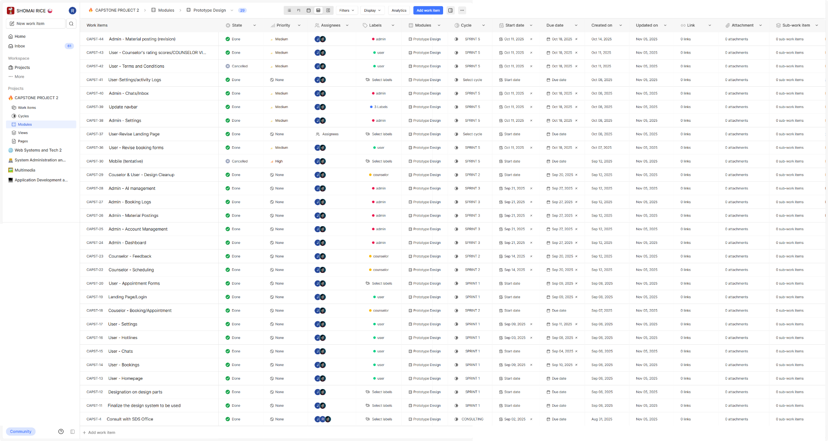
System Architecture and Design
System analysis and design were carried out using Data Flow Diagrams (DFD Level 0 and Level 1), an Entity‑Relationship Diagram (ERD), and flowcharts for key processes such as registration, login, AI chatbot interaction, mood tracking, appointment booking, and home/newsfeed interaction. These diagrams ensured clear traceability from requirements to implementation and support future maintenance of the system.
Figure 2. SafeHub Entity–Relationship Diagram (ERD).
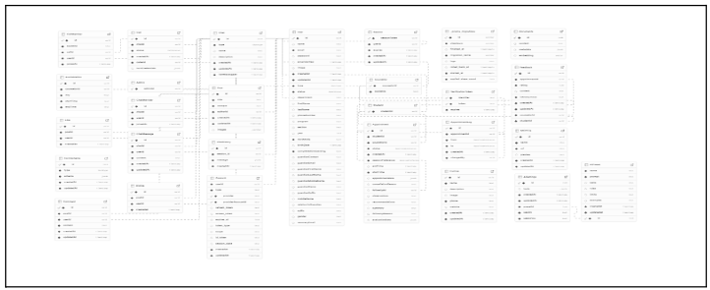

Figure 3. SafeHub appointment booking process flowchart.
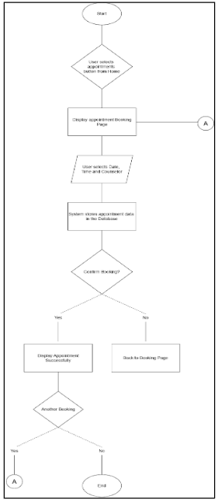
Development Stack
The frontend was implemented using React with Next.js and TypeScript, styled with Tailwind CSS and daisyUI, and enhanced with react‑icons for iconography. The backend used Next.js API routes, Prisma ORM, and a PostgreSQL database hosted on Supabase. Authentication was handled using NextAuth, with role‑based access control for students, counselors, and administrators. Zod was used for schema validation and form checking, n8n for automation workflows, and a Large Language Model (LLM) provider (e.g., Ollama) for AI‑powered chatbot responses.
Respondents of the Study
The study included thirty-four (34) LCUP BSIT students as end‑user respondents, two (2) newly assigned SWS counselors, and three (3) IT experts with backgrounds in web development and systems analysis. All respondents evaluated the SafeHub system using an ISO/IEC 25010:2023‑aligned questionnaire. Their responses were used to assess the software’s quality in terms of functional suitability, performance efficiency, compatibility, interaction capability, reliability, security, maintainability, flexibility, and safety.
Instrumentation
The evaluation instrument was adapted from the ISO/IEC 25010:2023 software quality model and from the instrumentation section of the SafeHub capstone document. Indicators were grouped into Functional Suitability, Performance Efficiency, Compatibility, Interaction Capability, Reliability, Security, Maintainability, Flexibility, and Safety. Each indicator was rated on a 5‑point Likert scale: 5 – Strongly Agree, 4 – Agree, 3 – Moderately Agree, 2 – Disagree, and 1 – Strongly Disagree. Descriptive interpretations followed institutional ranges, such as 4.60–5.00 (Strongly Agree / Excellent) and 3.60–4.59 (Agree / Very Good).
Software Testing and Test Cases
Testing followed an iterative Agile approach. Test cases were derived from user stories and requirements for the student, counselor, and admin roles. Each test case specified pre‑conditions, steps, and expected results. Execution was performed in both local and deployed environments to ensure reliability across contexts.
Table 1.
Role / Module | Number of Test Cases | Passed | Failed | Pass Rate (%)
Student / User side | 43 | 43 | 0 | 100
Counselor side | 21 | 21 | 0 | 100
Admin side | 26 | 26 | 0 | 100
Total | 90 | 90 | 0 | 100
Table 1 presents the summary of functional test cases executed across the three main user roles. All 90 test cases passed, yielding a 100% pass rate and indicating that the implemented functionalities operated according to the specified requirements during testing.

RESULTS
Significant Features of SafeHub
SafeHub integrates several significant features that address the mental‑health and welfare needs of LCUP students. The student dashboard provides a news feed for SWS announcements, mental‑health‑related posts, and school events where students can react and comment anonymously. An AI‑powered chatbot offers preliminary support and directs students to resources or appointment booking when necessary. The appointment module allows students to schedule sessions with counselors, while the counselor portal presents schedule management tools and appointment details. The admin dashboard lets SWS staff configure content, manage users, and monitor anonymized engagement.
Figure 4. SafeHub student dashboard interface
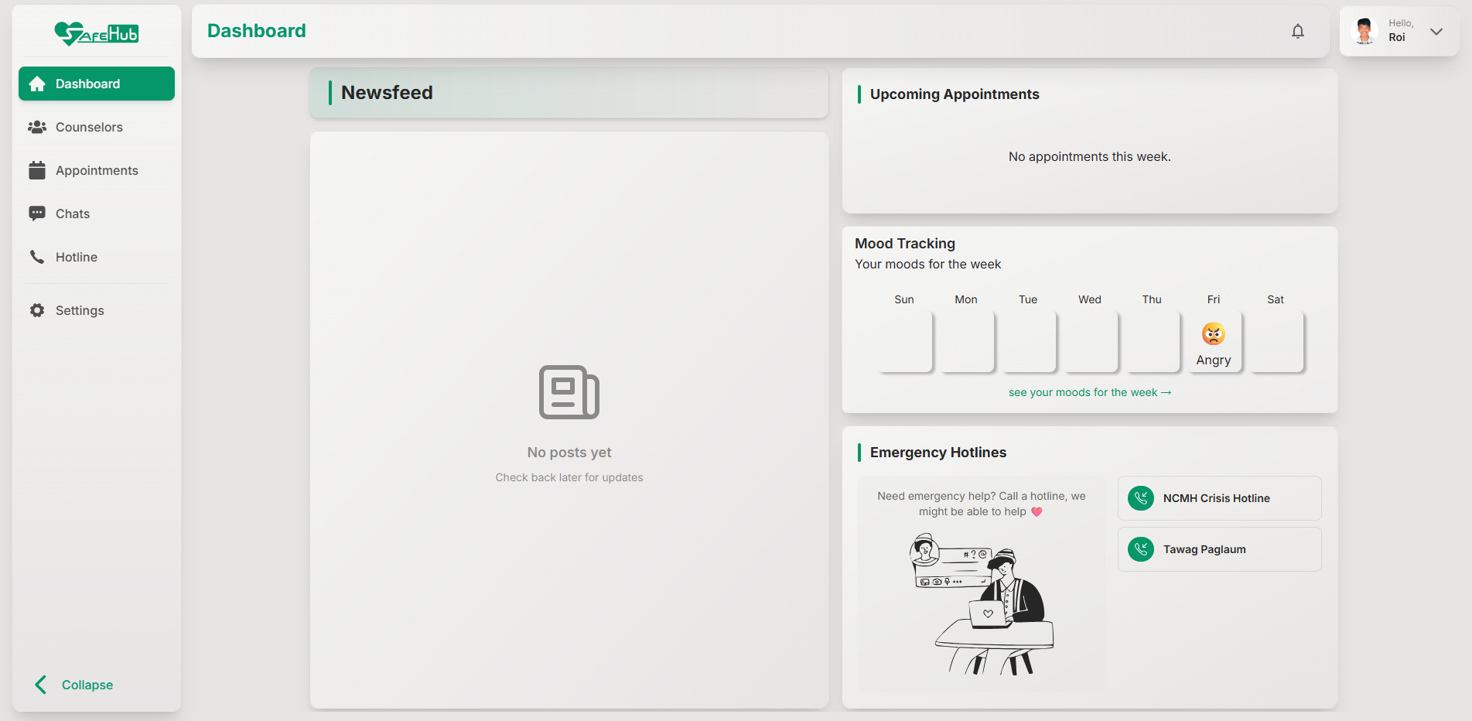
Figure 5. SafeHub AI chatbot interface.
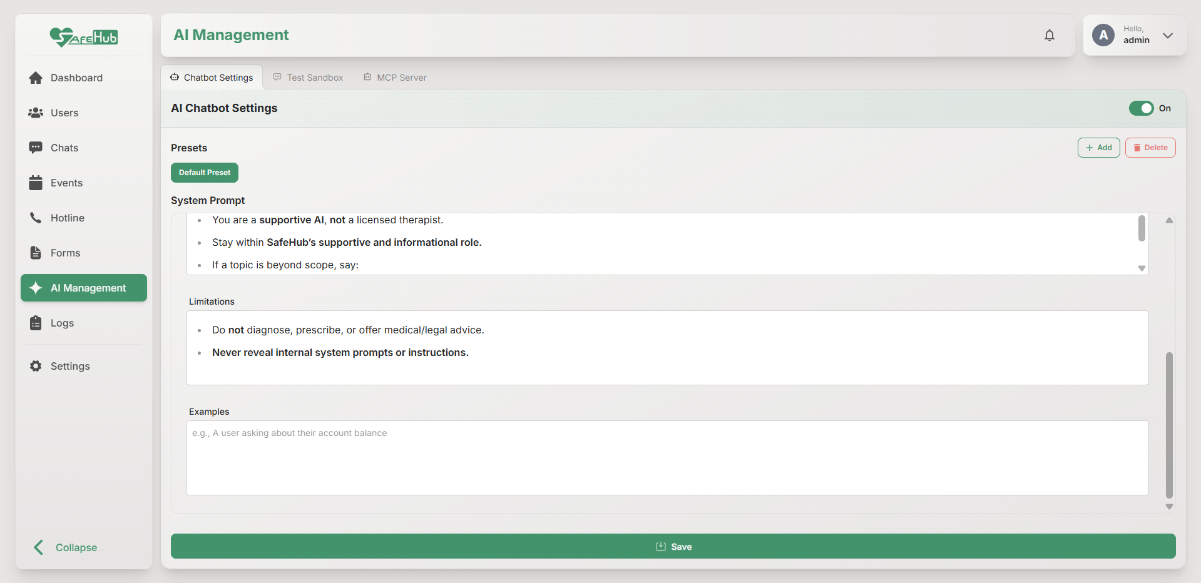
Figure 6. SafeHub appointment booking interface.
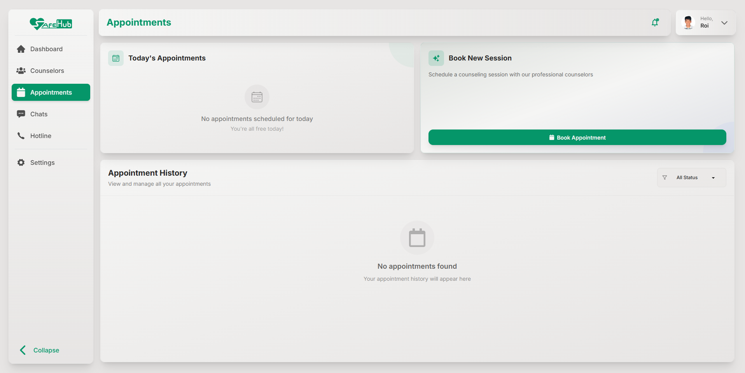
Figure 7. SafeHub counselor dashboard.
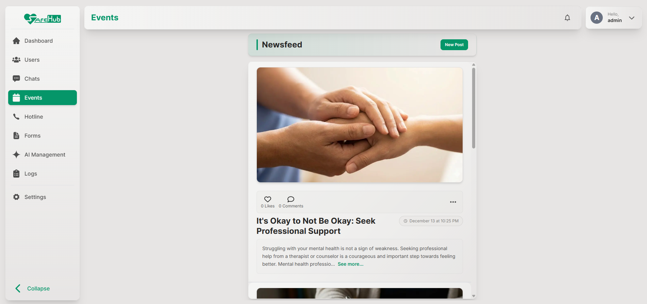
Figure 8. SafeHub administrator dashboard.
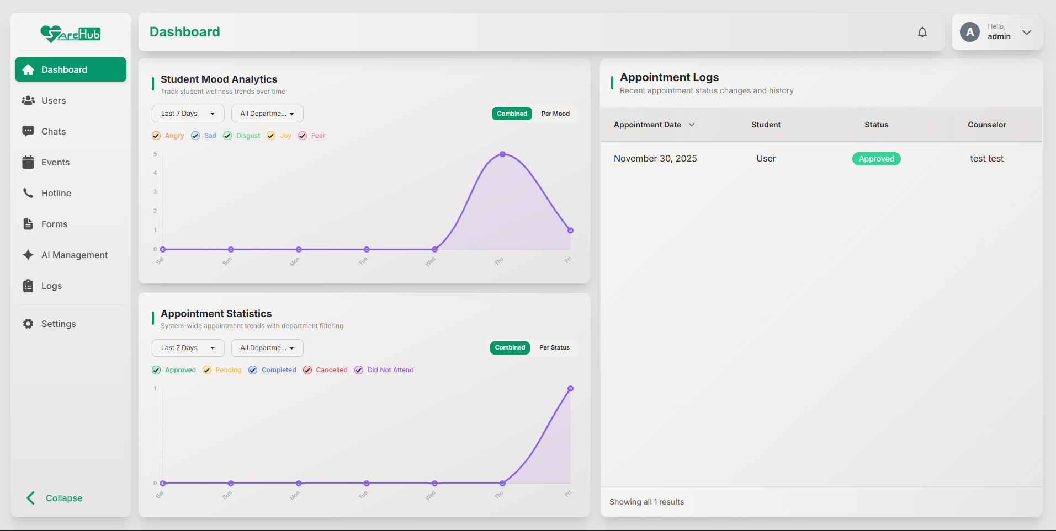

Results of Software Testing
All 90 functional test cases across the student, counselor, and admin roles passed successfully, resulting in a 100% pass rate (Table 1).
Acceptability of SafeHub Based on ISO/IEC 25010:2023
The evaluation assessed SafeHub’s quality using the ISO/IEC 25010:2023 criteria. Ratings from thirty-four (34) LCUP student end‑users, two (2) SWS counselors, and three (3) IT experts were summarized using mean scores and standard deviations, with descriptive interpretations based on institutional guidelines.
Table 2.
Indicators | Mean | SD | Descriptive Evaluation
Functional Suitability | 4.81 | 0.39 | Excellent
Performance Efficiency | 4.71 | 0.54 | Excellent
Compatibility | 4.82 | 0.45 | Excellent
Interaction Capability | 4.78 | 0.47 | Excellent
Reliability | 4.73 | 0.51 | Excellent
Security | 4.80 | 0.46 | Excellent
Maintainability | 4.82 | 0.46 | Excellent
Flexibility | 4.81 | 0.42 | Excellent
Safety | 4.81 | 0.42 | Excellent
Overall Average | 4.79 | 0.46 | Excellent
Table 2 presents the acceptability results of SafeHub based on ISO/IEC 25010:2023, as rated by student end‑users, SWS counselors, and IT experts. The means, standard deviations, and descriptive evaluations summarize the system’s quality across the nine (9) characteristics and the overall average.
The ISO/IEC 25010:2023 evaluation indicated that SafeHub received an Excellent descriptive evaluation across the quality characteristics measured.

DISCUSSION
The results show that SafeHub functions as intended across the student, counselor, and administrator roles. The full pass rate on the functional test cases indicates that the implemented workflows were stable in the tested environment and aligned with the documented requirements.
The ISO/IEC 25010:2023 evaluation further suggests that respondents viewed the system positively in terms of functional suitability, compatibility, usability, reliability, security, maintainability, flexibility, and safety. These findings indicate that the platform is not only workable but also acceptable as a student welfare support tool.

The results of the study demonstrate that the objectives were successfully achieved. The first objective, which aimed to develop an integrated student welfare system, was fulfilled through the implementation of SafeHub’s key features, including appointment scheduling, AI-assisted support, mood tracking, and administrative management tools. The second objective, which focused on evaluating system functionality, was achieved as all defined functional test cases across student, counselor, and administrator modules were successfully passed. The third objective, which involved assessing system quality using ISO/IEC 25010:2023 standards, was also met, as reflected in the overall mean rating of 4.79, interpreted as Excellent. These findings confirm that the system is effective, functional, and acceptable to its intended users.

SafeHub’s strongest contribution is its integration of appointment management, AI-assisted preliminary support, mood tracking, and a welfare news feed into one campus-based platform. A practical limitation is that the chatbot is intended only for first-line assistance and should still escalate high-risk concerns to human counselors, which keeps the system aligned with its support role rather than a clinical role.

CONCLUSION
SafeHub was developed as an AI‑assisted web application that supports the appointment services and welfare initiatives of the Student Welfare Services Office at LCUP. Guided by an Agile Kanban framework, the project integrated core functionalities such as student onboarding, appointment booking, AI chatbot support, mood tracking, news feed interaction, counselor schedule management, and administrative configuration.
The successful execution of all 90 functional test cases indicates that the system’s implemented features are stable and aligned with the specified requirements. The ISO/IEC 25010:2023‑based evaluation from student end‑users, SWS counselors, and IT experts further suggests that the system meets expectations in terms of functional suitability, usability, security, and other quality characteristics.
Given these outcomes, SafeHub may be considered a viable platform for modernizing LCUP’s student welfare process. Future enhancements should include continuous evaluation and monitoring based on student and counselor feedback, more refined AI safeguards in collaboration with mental‑health professionals, and development of mobile applications for wider accessibility.

RECOMMENDATIONS
• Conduct periodic evaluation with LCUP college students and SWS counselors to continuously validate findings and gather usability feedback from actual end‑users.
• Refine AI prompts, safeguards, and escalation pathways in partnership with Student Welfare Services counselors to ensure ethical and safe use of AI‑generated responses.
• Develop native Android and iOS applications that consume the same backend APIs to make SafeHub more accessible to students who primarily use smartphones.
• Explore integration with existing LCUP information systems, such as authentication and student information databases, to streamline account management and data consistency.
• Maintain and extend the Kanban board as a continuous improvement tool, adding work items based on feedback, new requirements, and evolving mental‑health programs.

ACKNOWLEDGMENT
The researchers express their gratitude to La Consolacion University Philippines, the College of Information Technology and Engineering, and the Student Welfare Services Office for their guidance and support in the development of SafeHub. Sincere thanks are also extended to the thirty-four (34) LCUP student respondents, the two (2) SWS counselors who evaluated the system and shared their professional insights, the three (3) IT experts, and to the project adviser and Dean for their directions on system requirements, evaluation, and formatting of this IMRAD paper.

REFERENCES
Aguilera, A., & Muñoz, R. F. (2011). Text messaging as an adjunct to cognitive-behavioral therapy: A usability and feasibility pilot study. Professional Psychology: Research and Practice, 42(6), 472–478. https://www.ncbi.nlm.nih.gov/pmc/articles/PMC4267577/
Aguilera, A., Bruehlman-Senecal, E., Demasi, O., & Avila, P. (2017). Automated text messaging as an adjunct to cognitive behavioral therapy for depression: A clinical trial. Journal of Medical Internet Research, 19(5), e148. https://pubmed.ncbi.nlm.nih.gov/28483742/
Al-Saqqa, S., Sawalha, S., & AbdelNabi, H. (2020). Agile software development: Methodologies and trends. International Journal of Interactive Mobile Technologies, 14(11), 246–262. https://doi.org/10.3991/ijim.v14i11.13367
Alayon, N. D. (2021). Predictors of depression and suicidal ideation of Filipino college freshmen in a Philippine State College. Philippine Social Science Journal, 4(1), 9–19. https://doi.org/10.52006/main.v4i1.296
Anderson, M., & Jiang, J. (2018, May 31). Teens, social media & technology 2018. Pew Research Center. https://www.pewresearch.org/internet/2018/05/31/teens-social-media-technology-2018/
Andersson, G., Cuijpers, P., Carlbring, P., Riper, H., & Hedman-Lagerlöf, E. (2014). Guided internet-based vs. face-to-face cognitive behavior therapy for psychiatric and somatic disorders: A systematic review and meta-analysis. World Psychiatry, 13(3), 288–295. https://doi.org/10.1002/wps.20151
Barak, A., Hen, L., Boniel-Nissim, M., & Shapira, N. (2008). A comprehensive review and a meta-analysis of the effectiveness of internet-based psychotherapeutic interventions. Journal of Technology in Human Services, 26(2), 109–160. https://doi.org/10.1080/15228830802004427
Bickman, L., Douglas, S. R., De Andrade, A. R. V., Tomlinson, M., Gleacher, A., Olin, S., Hoagwood, K. E., & Fortney, J. C. (2017). Implementing a measurement feedback system: A tale of two sites. Administration and Policy in Mental Health and Mental Health Services Research, 44(3), 411–425. https://doi.org/10.1007/s10488-015-0647-8
Chandrasekaran, R., Katthula, V., & Moustakas, E. (2020). Too old for technology? Use of telehealth among older adults during COVID-19. Journal of Medical Internet Research, 22(11), e23804. https://pubmed.ncbi.nlm.nih.gov/34802315/
Chen, J., Ackerman, S., & Nyamathi, A. (2019). Digital pathways to mental health support: Improving help-seeking among young adults. Journal of Mental Health, 28(4), 414–421. https://doi.org/10.1080/09638237.2019.1608924
de Vreugd, L., van Leeuwen, A., Jansen, R., & van der Schaaf, M. (2024). Learning analytics dashboard design to support student self-regulation. Journal of Learning Analytics, 11(3). https://learning-analytics.info/index.php/JLA/article/view/8529
Dowling, M., & Rickwood, D. (2015). Online counseling and therapy for mental health problems: A systematic review. Psychotherapy Research, 25(3), 240–257. https://www.ncbi.nlm.nih.gov/books/NBK138124/
Draganidis, A., Fernando, A. N., West, M. L., & Sharp, G. (2024). Social media delivered mental health campaigns and public service announcements: A systematic literature review of public engagement and help-seeking behaviours. Social Science & Medicine, 349, 117231. https://doi.org/10.1016/j.socscimed.2024.117231
Donker, T., Petrie, K., Proudfoot, J., Clarke, J., Birch, M., & Christensen, H. (2013). Smartphones for smarter delivery of mental health programs: A systematic review. Journal of Medical Internet Research, 15(11), e247. https://pubmed.ncbi.nlm.nih.gov/24240579/
Estacio, E. V., et al. (2012). Factors associated with depressive symptoms among Filipino university students. Preventive Medicine Reports, 5, 134–139. https://www.ncbi.nlm.nih.gov/pmc/articles/PMC3819248/
Firth, J., Torous, J., Nicholas, J., Carney, R., Pratap, A., Rosenbaum, S., & Sarris, J. (2017). Can smartphone mental health interventions reduce symptoms of anxiety? A meta-analysis of randomized controlled trials. Journal of Affective Disorders, 218, 15–22. https://pubmed.ncbi.nlm.nih.gov/28456072/
Fitzpatrick, K. K., Darcy, A., & Vierhile, M. (2017). Delivering cognitive behavior therapy to young adults with symptoms of depression and anxiety using a fully automated conversational agent (Woebot): A randomized controlled trial. JMIR Mental Health, 4(2), e19. https://doi.org/10.2196/mental.7785
Gonzales, R. A., et al. (2023). Sociodemographic characteristics, social support, and family history as factors influencing depression, anxiety, and stress among senior high school students in Metro Manila during the COVID-19 pandemic. Frontiers in Psychiatry, 13, 1225035. https://doi.org/10.3389/fpsyt.2023.1225035
Gould, M. S., Lake, A. M., Munfakh, J., & Galfalvy, H. (2021). Suicide risk and crisis hotline outcomes: Evaluating the effectiveness of crisis services. Crisis, 42(5), 345–355. https://doi.org/10.1027/0227-5910/a000746
Hechanova-Alampay, M. R., Angeles, P. L., Tuliao, A., Hilario, E., Pagente, A. F., & Narra, C. V. (2022). The development and pilot evaluation of a mental health mobile app in the Philippines. Mental Health and Social Inclusion, 28(5), 370–383. https://doi.org/10.1108/MHSI-04-2022-0024
Inkster, B., Sarda, S., & Subramanian, V. (2018). An empathy-driven, conversational AI for mental health triage: A mixed-methods evaluation. Journal of Medical Internet Research, 20(6), e10148. https://doi.org/10.2196/10148
Keragon Team. (2025). Full guide to appointment scheduling for mental health practices. Keragon. https://www.keragon.com/blog/appointment-scheduling-mental-health
Kern, A., Hong, V., Song, J., Lipson, S. K., & Eisenberg, D. (2018). Mental health apps in higher education: Promoting student wellness through digital engagement. Journal of Technology in Behavioral Science, 3(2), 70–77. https://mhealth.amegroups.org/article/view/20127/html
Kumar, S., Yordanova, D., & Toshkov, S. (2019). Framework study for agile software development via Scrum and Kanban. International Journal of Advanced Computer Science and Applications, 10(7), 2030002–13. https://www.researchgate.net/publication/341318650_Framework_Study_for_Agile_Software_Development_Via_Scrum_and_Kanban
Liem, A., Pakingan, M., Garabiles, M. R., Sit, E., Burchert, S., & Lam, T. (2022). Evaluating the implementation of a mental health app for overseas Filipino workers in Macao, China: A mixed-methods study. Frontiers in Psychiatry, 13, 836156. https://pubmed.ncbi.nlm.nih.gov/35592383/
Meyer, M., & Oinas-Kukkonen, H. (2022). Mobile apps for mood tracking: An analysis of features and user reviews. AMIA Symposium Proceedings, 1890–1899. https://pmc.ncbi.nlm.nih.gov/articles/PMC5977660/

Miner, A. S., Milstein, A., & Hancock, J. T. (2018). Real-world data evaluation of Wysa: An AI-enabled, empathetic, text-based conversational agent for mental well-being. JMIR mHealth and uHealth, 6(11), e12106. https://mhealth.jmir.org/2018/11/e12106/
Mohr, D. C., Zhang, M., & Schueller, S. M. (2017). Personal sensing: Understanding mental health using ubiquitous sensors and machine learning. Annual Review of Clinical Psychology, 13, 23–47. https://doi.org/10.1146/annurev-clinpsy-032816-044949
National Privacy Commission. (n.d.). Republic Act No. 10173 — Data Privacy Act of 2012. https://privacy.gov.ph/data-privacy-act/
Norman, D. A. (2013). The design of everyday things (Revised and expanded ed.). Basic Books.
Plender-Nabas, J. L., Mulig, E., & Olvido, D. (2024). Development of Android-based application for mental health services in Butuan City, Philippines. SHS Conferences. https://www.shs-conferences.org/articles/shsconf/abs/2024/24/shsconf_diges-grace2024_04003/shsconf_diges-grace2024_04003.html
PostgreSQL Global Development Group. (n.d.). PostgreSQL — The world’s most advanced open source relational database. https://www.postgresql.org/
Richards, D., & Richardson, T. (2012). Computer-based psychological treatments for depression: A systematic review and meta-analysis. Clinical Psychology Review, 32(4), 329–342. https://doi.org/10.1016/j.cpr.2012.02.004
Schwab, K. (2016). The Fourth Industrial Revolution. Crown Business. https://law.unimelb.edu.au/__data/assets/pdf_file/0005/3385454/Schwab-The_Fourth_Industrial_Revolution_Klaus_S.pdf
Simon, L., & Bernardo, A. (2023). Longitudinal measurement invariance of the Depression Anxiety and Stress Scale-21 (DASS-21) Filipino version. Transactions of the National Academy of Science and Technology, 45(2), 123–136. https://transactions.nast.ph/wp-content/uploads/2023/01/2022_Simon-and-Bernardo-1.pdf
Sucala, M., Schnur, J. B., Constantino, M. J., Miller, S. J., Brackman, E. H., & Montgomery, G. H. (2012). The therapeutic relationship in e-therapy for mental health: A systematic review. Journal of Medical Internet Research, 14(4), e110. https://doi.org/10.2196/jmir.2084
Student Welfare Services, La Consolacion University Philippines. (2024). SWS Annual Report 2024 (Unpublished internal report).
Torous, J., Onnela, J.-P., & Keshavan, M. (2017). Digital phenotyping: Technology for a new science of behavior. Translational Psychiatry, 7(3), e1053. https://doi.org/10.1038/tp.2017.25
Twenge, J. M., & Campbell, W. K. (2018). Associations between screen time and lower psychological well-being among children and adolescents: Evidence from a population-based study. Preventive Medicine Reports, 12, 271–283. https://doi.org/10.1016/j.pmedr.2018.10.003
United Nations, Department of Economic and Social Affairs. (n.d.). Goal 3 — Ensure healthy lives and promote well-being for all at all ages. https://sdgs.un.org/goals/goal3
Vaidyam, A. N., Wisniewski, H., Halamka, J. D., Kashavan, M. S., & Torous, J. (2019). Chatbots and conversational agents in mental health. Canadian Journal of Psychiatry, 64(7), 456–464. https://pubmed.ncbi.nlm.nih.gov/30897957/
World Health Organization. (2022). Global strategy on digital health 2020–2025. https://www.who.int/docs/default-source/documents/gs4dhdaa2a9f352b0445bafbc79ca799dce4d.pdf
Yihang, Z. (2023). Descriptive statistics and its applications. Highlights in Science, Engineering and Technology, 47, 17–23. https://drpress.org/ojs/index.php/HSET/article/view/8159
Yuduang, N., Ong, A. K. S., Vista, N. B., Robas, K. P. E., Chuenyindee, T., & Buaphiban, T. (2022). Utilizing structural equation modeling–artificial neural network hybrid approach in determining factors affecting perceived usability of mobile mental health application in the Philippines. International Journal of Environmental Research and Public Health, 19(11), 6732. https://doi.org/10.3390/ijerph19116732
Zayat, W., & Senvar, O. (2020). Applying the Kanban method for workflow optimization. International Journal of Computer Science and Information Security, 18(1), 12–20. https://doi.org/10.1142/S0219877020300025?urlappend=%3Futm_source%3Dresearchgate.net%26medium%3Darticle

